**SPRING CRUD OPERATIONS**

**Continuation to Exp8 CRUD Operations**

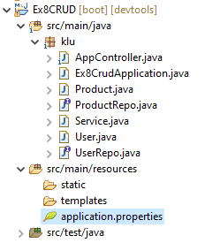

**User.java**

----------------------------------------------

import jakarta.persistence.Entity;

import jakarta.persistence.Id;

@Entity

public class User {

@Id

String un;

String pw;

String role;

public String getUn() {

return un;

}

public void setUn(String un) {

this.un = un;

}

public String getPw() {

return pw;

}

public void setPw(String pw) {

this.pw = pw;

}

public String getRole() {

return role;

}

public void setRole(String role) {

this.role = role;

}

@Override

public String toString() {

return "User [un=" + un + ", pw=" + pw + ", role=" + role + "]";

}

}

.......................................................................................................................................................

**UserRepo.java**

----------------------------------------------

**import** org.springframework.data.jpa.repository.JpaRepository;

**public** **interface** UserRepo **extends** JpaRepository<User, String>

{

**public** User findByUn(String un);

}

--------------------------------------------------------------------------------------------------------

**Service.java**

----------------------------

**package com.klu;**

**import** java.util.List;

**import** org.springframework.beans.factory.annotation.Autowired;

@org.springframework.stereotype.Service

**public** **class** Service {

@Autowired

ProductRepo repo1;

@Autowired

UserRepo repo2;

**public** String insertData(Product product) {

repo1.save(product);

**return** "Insertes Successfully";

}

**public** String updateData(Product product)

{

**if**(repo1.findById(product.getId())!=**null**)

repo1.delete(product);

repo1.save(product);

**return** "Updated successfully";

}

**public** String deleteData(**int** id)

{

repo1.delete(repo1.findById(id).get());

**return** "Deleted successfully";

}

**public** List<Product> retrieveData()

{

**return** repo1.findAll();

}

**public** String insertUser(User user) {

repo2.save(user);

**return** "success";

}

**public** String checkUser(User user) {

User userRetrieved = repo2.findByUn(user.getUn());

**if** (userRetrieved != **null**) {

**if** (userRetrieved.getPw().equals(user.getPw())) {

**return** userRetrieved.getRole();

} **else** {

**return** "0";

}

} **else** {

**return** "0";

}

}

}

------------------------------------------------------------------------------------------------------

**AppController.java**

----------------------------------------------

package com.klu;

**import** java.util.List;

**import** org.springframework.beans.factory.annotation.Autowired;

**import** org.springframework.web.bind.annotation.DeleteMapping;

**import** org.springframework.web.bind.annotation.GetMapping;

**import** org.springframework.web.bind.annotation.PathVariable;

**import** org.springframework.web.bind.annotation.PostMapping;

**import** org.springframework.web.bind.annotation.PutMapping;

**import** org.springframework.web.bind.annotation.RequestBody;

**import** org.springframework.web.bind.annotation.RestController;

@RestController

@CrossOrigin

**public** **class** AppController {

@Autowired

Service s;

//http://localhost:8080/product

@PostMapping("/product")

**public** String insertProduct(@RequestBody Product product)

{

**return** s.insertData(product);

}

//http://localhost:8080/product

@PutMapping("/product")

**public** String updateProduct(@RequestBody Product product)

{

**return** s.updateData(product);

}

//http://localhost:8080/product/111

@DeleteMapping("/product/{id}")

**public** String updateProduct(@PathVariable("id") **int** id)

{

**return** s.deleteData(id);

}

//http://localhost:8080/product

@GetMapping("/product")

**public** List<Product> retrieveProduct()

{

**return** s.retrieveData();

}

//http://localhost:8080/user

@PostMapping("/user")

**public** String insertUser(@RequestBody User user)

{

**return** s.insertUser(user);

}

//http://localhost:8081/check

@PostMapping("/check")

**public** String retrieveUser(@RequestBody User user) {

**return** s.checkUser(user);

}

}

........................................................................................................................................................

------------------------------------------------------------------------------------------------------

**Insertion operation** :

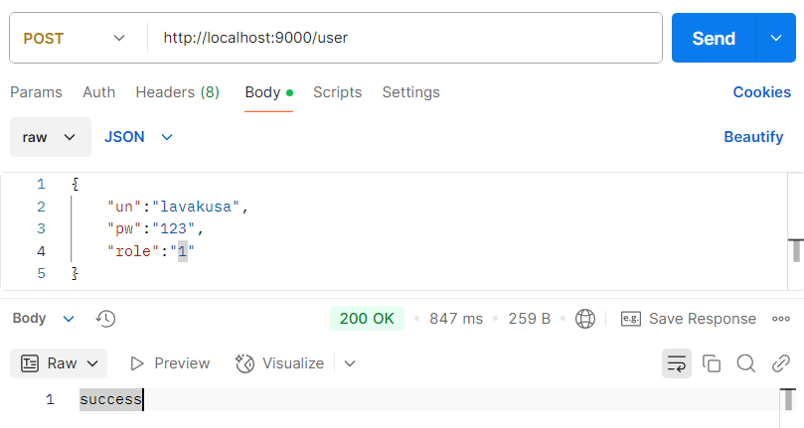

**Retrieval Operaton:**

